Purpose:
To enable you to choose between several different courses of action by providing a structured method for exploring options and weighing up potential risks and rewards.
Directions:
Step 1: Draw a square halfway down the left-hand side of your sheet of paper, to represent the decision.
Step 2: Draw a line leaving the box at an angle, to represent each possible course of action. Label each line so you know what it represents.
Step 3: At the end of each line, draw another square, to represent another decision to be made, an uncertain outcome (sometimes drawn as a circle) or leave blank to represent a certain outcome (sometimes drawn as a triangle). Label each of these.
Step 4: From each square, draw further lines and repeat Step 3 until you have covered all of the possible options, decisions and outcomes.
Circle= Decision; Square= Uncertainty (External event)
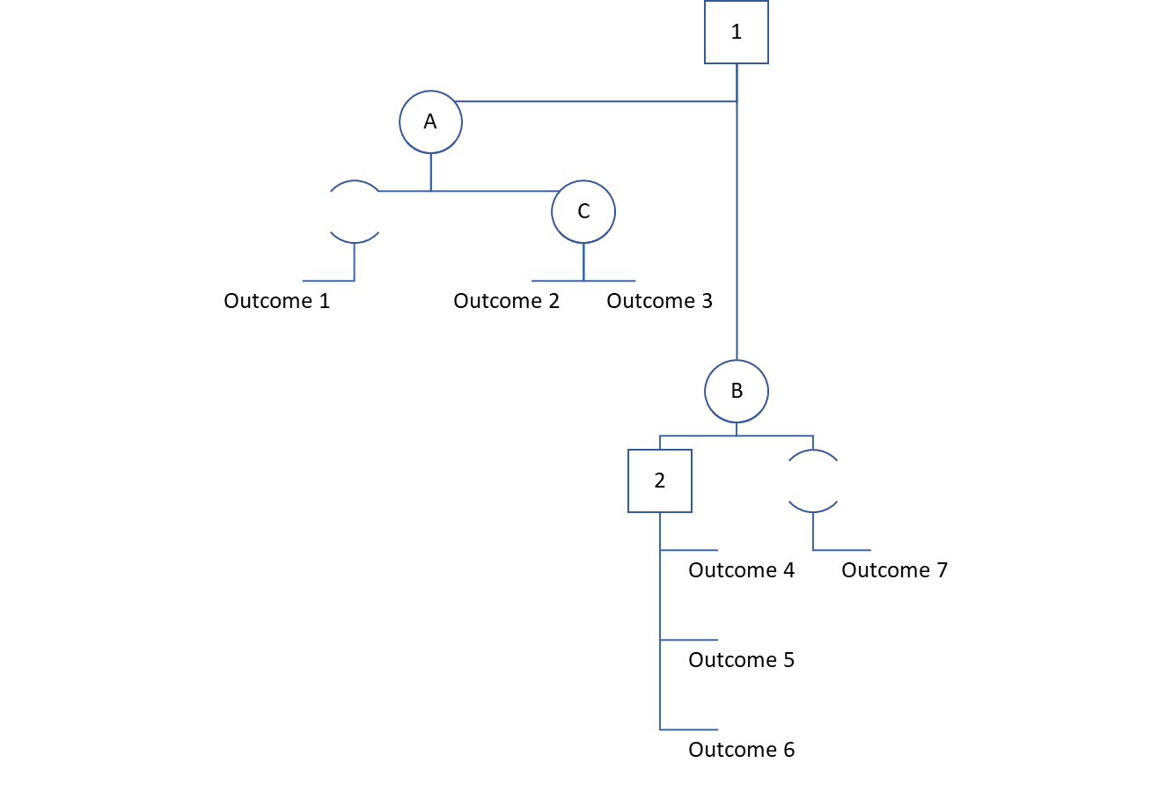

Evaluating the Decision Tree
Step 5: The point at which each line ends, with no further decisions or uncertain outcomes, represents a known outcome and the next step is to allocate a value to that outcome i.e. what will be the financial benefit of that outcome.
Step 6: Wherever you have an uncertain outcome, assign a probability to each potential outcome which could result. Together, all of the percentages of all of the potential outcomes from any point of uncertainty must add up to 100%.

Calculating the Decision Tree Values
Step 7: Start calculating values on the right hand side of the tree. Wherever you have a point of uncertainty, you should multiply each of the outcome values by the probability that they will occur. For each point of uncertainty, all of the resulting amounts should be added together, to give the outcome value for that point of uncertainty.
Step 8: Wherever you have a decision node, record the cost of making that decision along each decision line. Then subtract that cost from each of the outcome values that you have already recorded. This will give you a value that represents the benefit of that decision – i.e. the benefit, less the cost.

Result: Applying this technique enables you to see which the best option is.
Example:
A small business needs to decide if it will be worthwhile paying to attend a local business exhibition.
If they decide not to attend, there will be no cost to this, but equally, no sales will result.
If they decide to attend, they do not know what sales they will get as a result. However, based on previous experience, they believe that they will have a 10% chance of making no sales at all as a result, a 60% chance of making £4,000 of sales and a 30% chance of making sales of £10,000. It will cost £2,000 to exhibit.

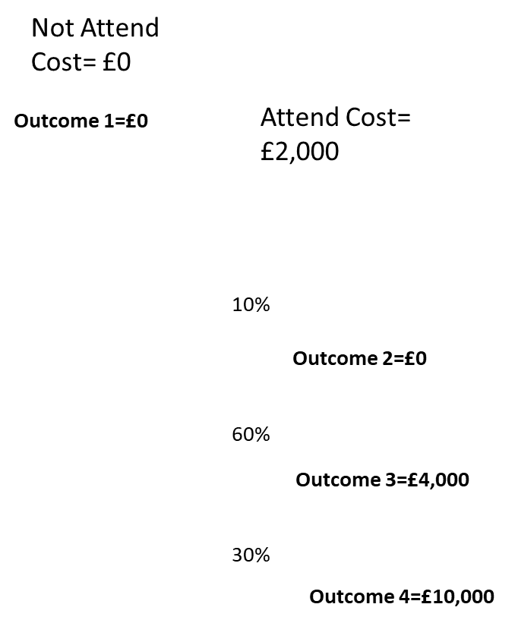

10% of £0 plus 60% of £4,000 plus 30% of £10,000 equals £5,400. When the cost of attending is subtracted, this puts a value of £3,400 on attending the exhibition and £0 on not attending it. Therefore, the decision tree analysis would suggest that attending the exhibition is the right course of action.
Additional Information:
Decision trees are a useful tool because they allow us to consider all of the possible options and organise all of the information about the values of outcomes and the probability of achieving them into one place.

