Purpose:
To determine whether to coach or not, and what to coach and what not to coach
This model provides a framework for determining whether coaching is an appropriate part of the solution and whether the underlying issue is about aptitude, attitude or the availability of resources.

The AAA Model
The level of success resulting from coaching is dependant to a large part on the appropriate levels of aptitude, attitude and resources. If any of the three are missing, the likelihood of a successful outcome is reduced.
Aptitude | This is the know-how, the skills and ability required to perform
Attitude | This is about the drive, motivation, confidence and focus required to perform
Availability of Resources | This is about the equipment, tools and time required to perform

Knowing when to coach and when not to coach is as important as having the knowledge and skills to be able to coach. An individual’s performance is affected by many things including skills and abilities (aptitude), motivation, focus and self-belief (attitude) and external factors such as the availability of time and resources. Some of these things might be outside of an individual’s direct control (e.g. market conditions or determining resource budgets), but other things might be under their direct control (e.g. influencing stakeholder relationships, the allocation or distribution of a resource allocation).

Directions:
1. Use the flow chart below as it describes a series of steps that can be used to determine if the challenges lie in the individual’s aptitude, attitude or resources.
2. Remember, the solution may not be coaching, or it may not only just be coaching – sometimes it might require a combination of inputs and interventions such as training or the negotiation of additional resources.
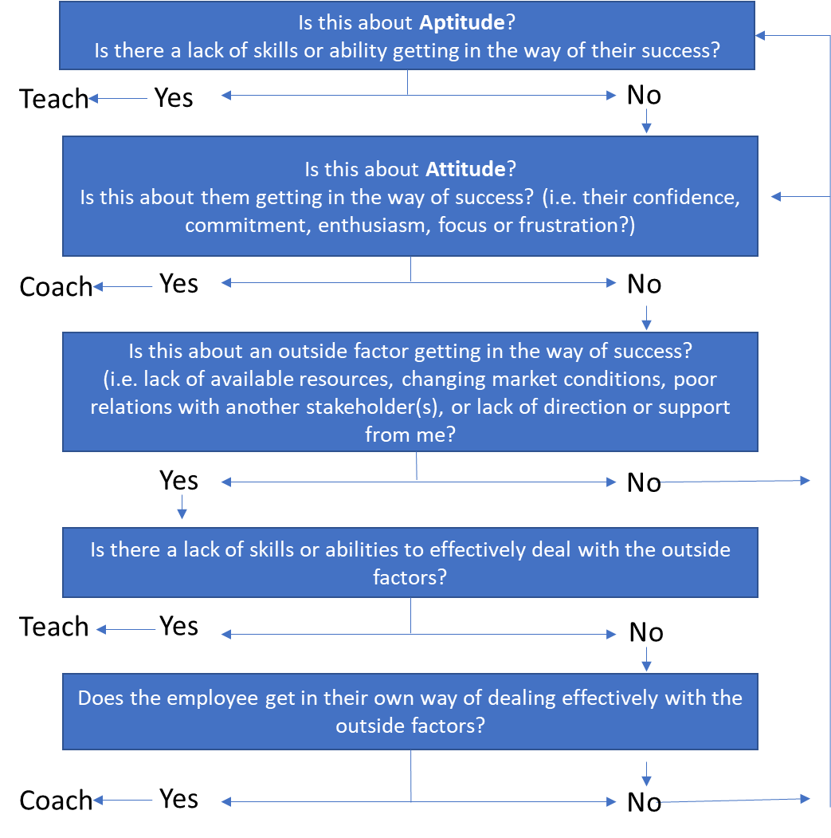
3. Although the AAA Coaching Model is for use by the coach, it can be also be used with clients by engaging the client to work through the flowchart with the coach rather than just as a process lead discussion by the coach.

