Purpose: To identify the root cause of a problem
Although deceptively simple the Five Whys technique provides a powerful framework for identifying the root cause of a problem. It simply involves asking five times, why the problem exists in order to get to the root cause of the problem.
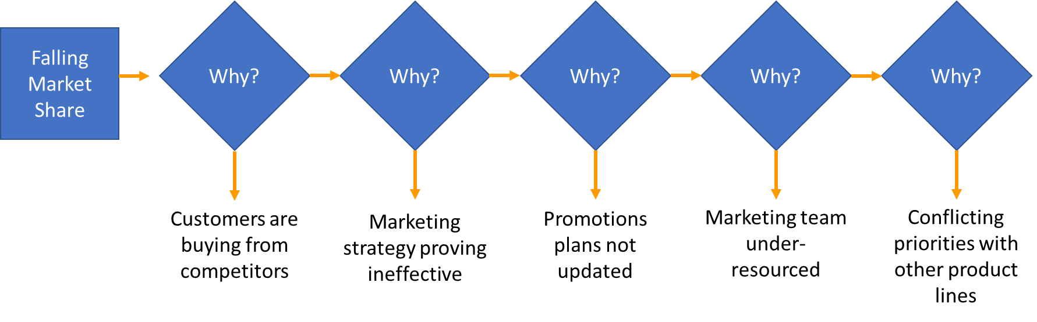
The Five Whys chart shown above demonstrates the level of analysis that can be generated by working through five levels of why.

Directions:
Step 1: Ask the question 'why'.
Step 2: Taking the answer resulting from the previous step and ask the question 'why'.
Step 3: Repeat Step 2
Step 4: Repeat Step 2
Step 5: Repeat Step 2

Each answer generates a potential source of further investigation, enabling you to drill down deep into the root cause of a problem. This tool is particularly effective when working with teams as often their knowledge and experience of a process provides a level of insight that would otherwise not be accessible.

Additional Information:
If more than one reason results, both can be investigated, as in the diagram below, which demonstrates the level of insight that can be achieved using this tool.

