Purpose:
The purpose of the Ishikawa Diagram (often referred to as Fish Bone Diagrams or Cause and Effect Charts) is to examine an issue or problem to find out the possible causes and to identify potential areas for improvement or further investigation.

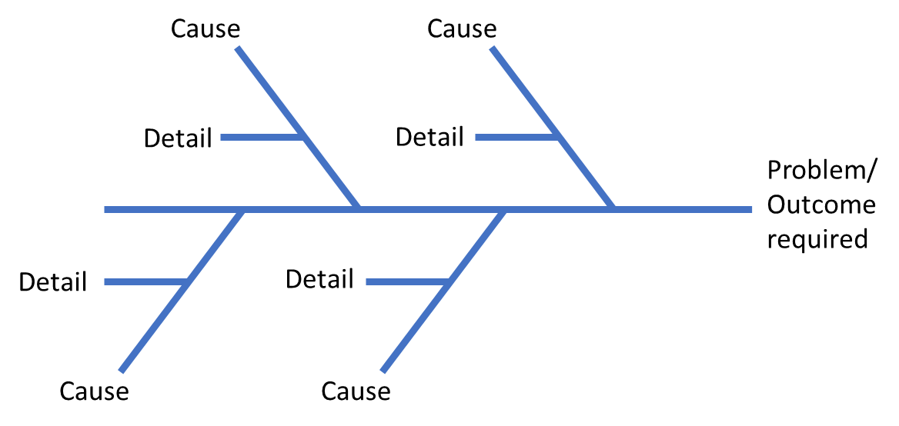

Directions:
Step 1: Brainstorm or list all possible causes of the problem or effect selected for analysis
Step 2: Classify the problem as either Materials, Methods, Machinery or Manpower (or use your own categories)
Step 3: Draw the solution effect diagram as above
Step 4: Write the effects on the diagram under the classifications chosen
Additional Information:
Often, when a problem is being analysed, it is tempting to look for temporary solutions or quick fixes that do not solve the root cause of the problem but merely address the symptoms. The Ishikawa diagram allows you to fully explore and understand the problem and consider all the potential areas for improvement and development. It can be used to stimulate discussion and effective team working.

